

**INSTALLATION MANUAL**

### **Table of Contents**

### **Applicable Version………………..…....……………………………….…………………….2**

### **Configuring Ingenico………………..…………………………………………………………2**

### **Feature List ……….....………………..…………………………………………………………4**

### 

### **Applicable versions**

|  |  |
| --- | --- |
| **Applications** | **Versions** |
| .NET Framework | 4.6.1 |
| MVC | 5.2.4 |

### **Configuring Ingenico**

1. Go-to http://<your-hostname>/payment/admin
2. Scroll down. You will see ingenico, Edit it
3. Configure it as below:

|  |  |
| --- | --- |
| **Column Name** | **Description** |
| Status | “Enable” to enable and use, else “Disable” to disable ingenico |
| Merchant Code | Enter Merchant Code |
| Salt | Enter Salt. |
| Payment Type | For Test mode Select ‘Test’ and for Live mode select ‘Live’ |
| Merchant Scheme Code | Enter Scheme Code |

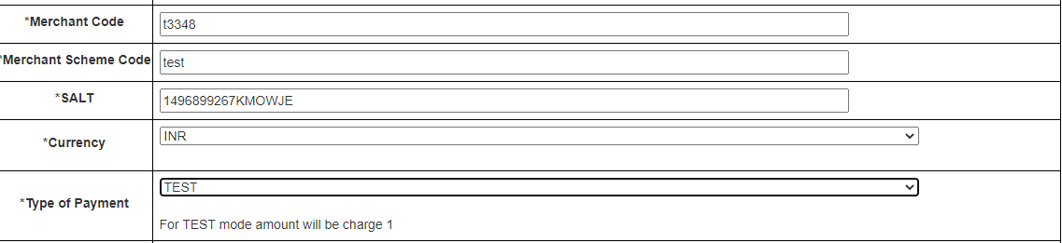

1. Now click on “Submit” at the bottom of the page
2. Ingenico Payment Gateway is now configured & ready to use.

### **Advanced Configuration**

There are also some advanced configuration options you may consider as shown below:

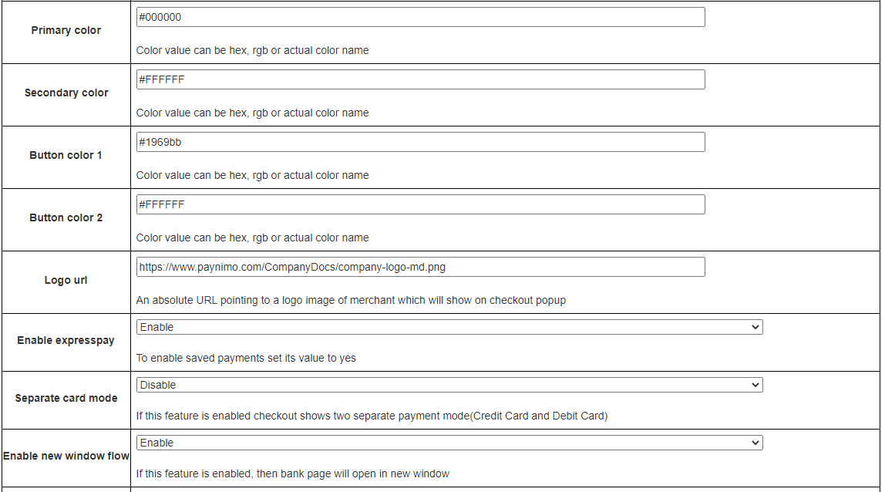

## **Features List**

### **Online Transaction**

To make an online transaction go to http://<your-hostname>

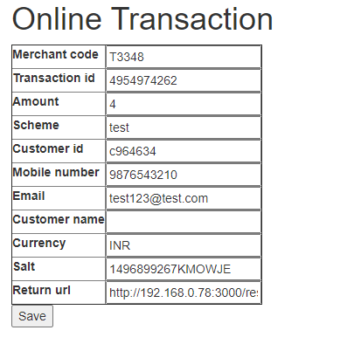

### **Dual verification of response**

We are validating responses with a hash value and call again Payment Gateway for dual verification from the payment gateway before updating to the order status.

### **Reconciliation**

Merchants can update the pending status of the order automatically if the payments are successful. This page can be found at [http://<your-hostname>/payment/reconcile](http://localhost:3000/payment/reconcile)

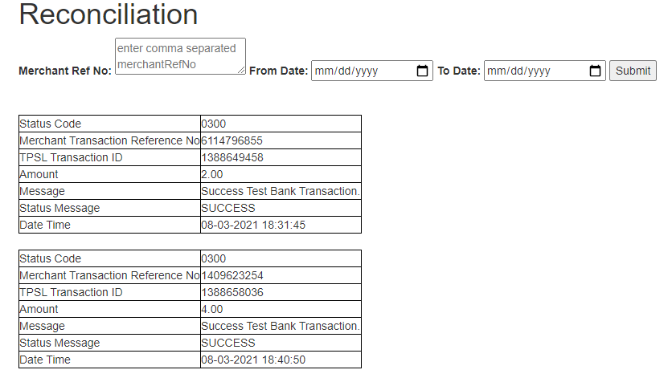

### **S2S Verification**

If we do not receive any response from the payment gateway then after 30 mins, we will get a response from the server and based on the response it will update order status.

To configure S2S URL, contact prod team.

S2S url format : http://<your-hostname>/payment/s2s?msg=

Example:

http://<your-hostname>/payment/s2s?msg=0300|success|NA|4917870142|470|1385982985|4.00|{email:test123@test.com}{mob:9876543210}|05-03-2021 13:08:08|NA||TEST BANK|1111385982985||e0adaa44-ff08-441b-a691-bb33bdc2803d|0a358c2201e4b1deff14bd42d3e6afb626d1e59fa5c763079442ba226351d463f23296de9cb8564d1e74e8a20ddc4996d86eb703f4a936115970985248ae6030

### **MCG**

It supports the multi-currency like INR & USD and a lot more can be added.

### **Offline Verification**

Merchants can verify the status of their payment by using the Payment Verification page. The payment verification page can be found at [http://<your-hostname>/payment/offline-verification](http://localhost:3000/payment/offline-verification)

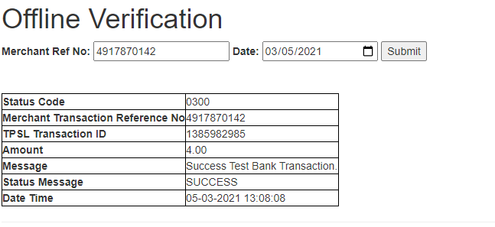

### **Refund**

Merchants should be able to process the refund online for the order whose payment has been done via Ingenico.

To refund an order go to [http://<your-hostname>/payment/refund](http://localhost:3000/payment/refund)

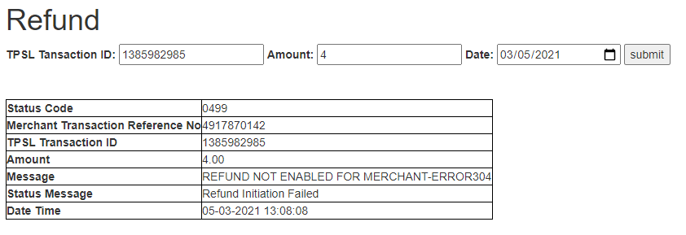

### **Embed Payment Gateway**

After enabling this setting, payment gateway displays like embedded on the page instead of pop-up so user experience would be good.

**E-mandate/E-Nach/SI**

**Configuration**

## **Features List**

### **Mandate Verification**

Merchants can verify the status of their Registered Mandate/SI by using the Mandate Verification page.

The Mandate verification page can be found at

[http://<your-hostname>/emandateSi/mandateVerification](http://localhost:3000/payment/offline-verification)

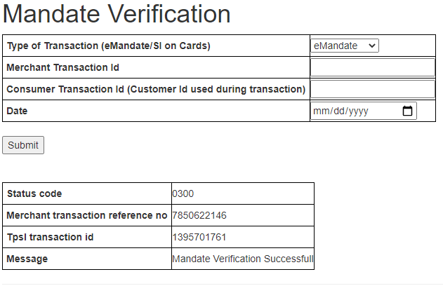

### **Transaction Scheduling**

Merchants can Schedule their Transaction for Mandate/SI by using the Transaction Scheduling page.  
The Transaction Scheduling page can be found at

http://<your-hostname>/emandateSi/transactionScheduling

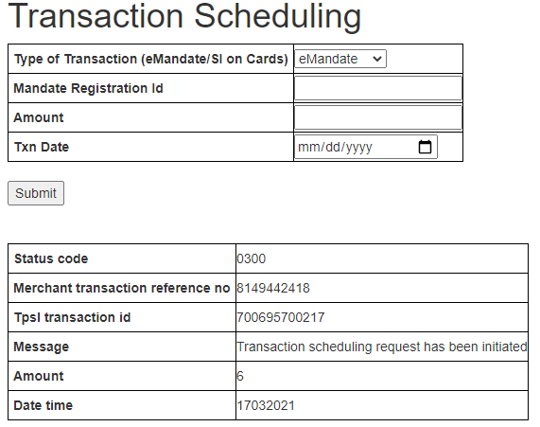

### **Transaction Verification**

Merchants can verify the status of their Scheduled Transaction for Mandate/SI by using the Transaction Verification page.

The Transaction Verification page can be found at

http://<your-hostname>/emandateSi/transactionVerification

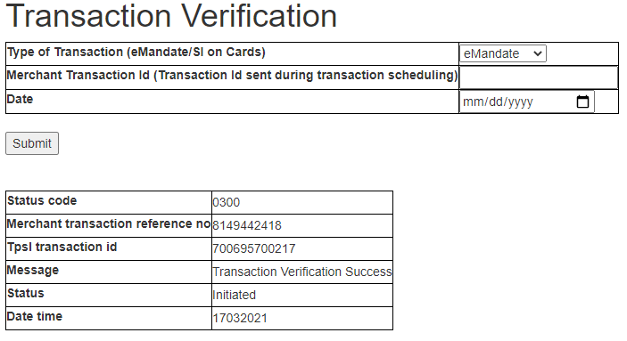

### **Mandate Deactivation**

Merchants can deactivate the registered Transaction for Mandate/SI by using the Mandate Deactivation page.

The Mandate Deactivation page can be found at

[http://<your-hostname>/emandate-si/mandate-deactivation](http://localhost:3000/payment/offline-verification)

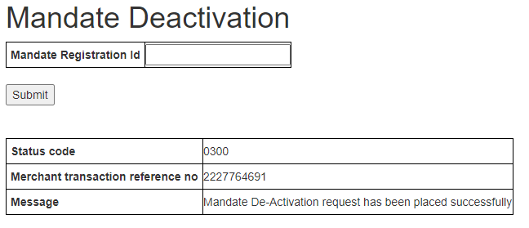

### 

### **Stop Payment**

Merchants can Stop the scheduled transaction by using the Stop Payment page.

The Stop Payment page can be found at

http://<your-hostname>/emandateSi/stopPayment

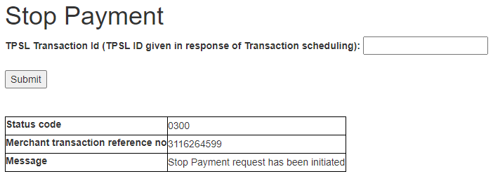

## **Documentation link**

[**https://www.tecprocesssolution.com/proto/p2m/client/salt-based-documentation.htm#online**](https://www.tecprocesssolution.com/proto/p2m/client/salt-based-documentation.htm#online)